## Wikipedia API Return JSON Objects

**Representation of a JSON Object, returned from the Wikipedia API:**

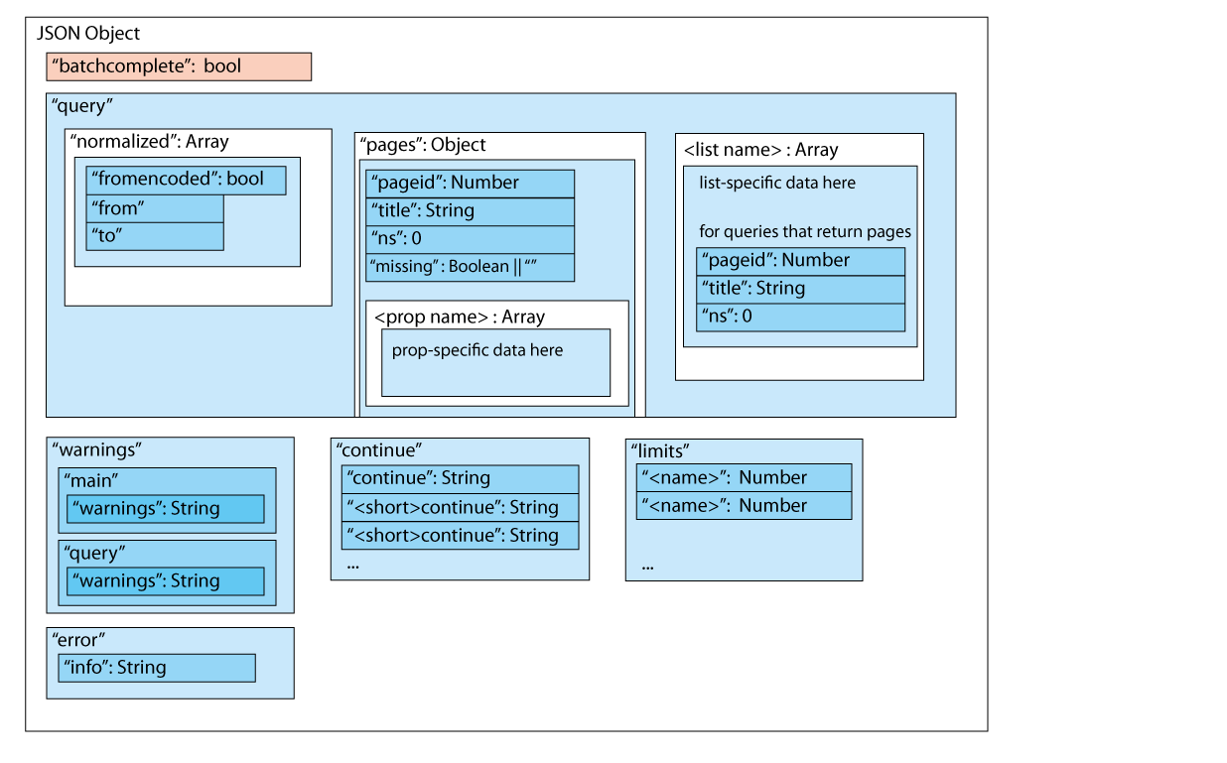

**Explanation of specific parts of the returned JSON Object:**

|  |  |
| --- | --- |
| batchcomplete | The attribute is used as a flat to represent whether the request was entirely completed.  If response is too large to be sent as one and there is still data in continue to be used to send the next request, batchcomplete = false  If all the data was sent and no errors occurred, batchcomplete = true |
| continue | The attribute is used as a way for user to continue the request, if it was too for a single response. The continue or any similar attributes should then be specified in the url as a parameter and should not be altered.  The specific keys are formed by adding the short form of the prop or list to continue word (For revisions it will be rvcontinue=’String’) |
| warnings | Are used to warn that something is wrong in the request. Mostly refer to wrong names of parameters or their values. This most often means that the response is lacking information and should be treated as an error in the program. |
| error | An attribute, describing the error due to which your request could not be handled by the server. Most likely it will be one of:   * HTTP request timed out. * Pool queue is full |
| limits | An object, representing the maximum amounts of a specific item, that can be sent back from server in a single response.  The keys of the object are the names of the params of list queries – corresponding to the params and list parameters in the url. The values are numbers, saying the maximum amount of revisions (prop=revisions), pages (list=allpages), etc. items |
| query | An object - the main part of the response, representing all the information that was required from the server. |
| normalized | An Array of js objects, containing information about whether the requested page title (most likely set in the titles param of the url) was wrongly formatted and needed to be normalized on the server to get valid information.  This happens when the name contains underscores ‘_’ in it instead of ‘ ‘ (encoded in the url as %20) or was encoded in ASCII (‘fromencoded’=true).  The server will then provide the user with the appropriate representation of the same name (in the ‘to’ attribute). |
| pages | An Object or an Array, containing all the pages, that were requested by the prop query (the required pages are specified in the titles or the ids url parameter)  Each valid page has the following attributes:   * title: String, name of the page * pageid: Number, unique page id * ns: Number of the namespace the page is in. Used internally in the Wikpedia   If the page was not found, the ‘missing’ attribute is set to true and some of the previously mentioned page attributes may be missing |
| props | Props (responses, sent to the prop=<name> parameter set in the url)  They are sent in the ‘query’ as part of a page. Each page will then contain an attribute with the name of the property as its name and the result as a value.  The result will be an array of Objects, containing all the data, depending on the request.  (For rvprop=timestamp, the object will just have a timestamp attribute) |
| lists | Lists (responses, sent to the list=<name> parameter set in the url)  They are sent directly in the query object, as they are not connected to any specific single page – you do not need to specify page title or id for lists in the request.  The key of the attribute will be the name of the list and the value will be an Array of Objects containing required information. |

**Examples with specified parameters in the request** (Try it contains the actual url):

|  |  |  |  |  |  |
| --- | --- | --- | --- | --- | --- |
| [TRY](https://en.wikipedia.org/w/api.php?action=query&titles=Main_Page&prop=revisions&rvprop=content&format=jsonfm) **IT!** | **action = query** | **prop = revisions** | **rvprop = content** | **titles = Main_Page** | **format = jsonfm** |

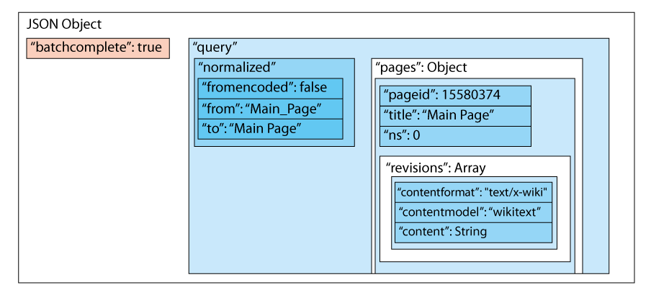

Batchcomplete tells us, that our request was successful. The revisions, as they should be (because they are a prop) are inside our page. They contain a single revision, because that is the default for revisions (rvlimit could be set to extend the number up to 50 revisions). The revision then contains the content of the page, as a String.

|  |  |  |  |  |  |
| --- | --- | --- | --- | --- | --- |
| [TRY IT!](https://en.wikipedia.org/w/api.php?action=query&list=allpages&aplimit=max&apdir=ascending&formatversion=2) | **action = query** | **list = allpages** | **aplimit = max** | **apdir= ascending** | **format = jsonfm** |

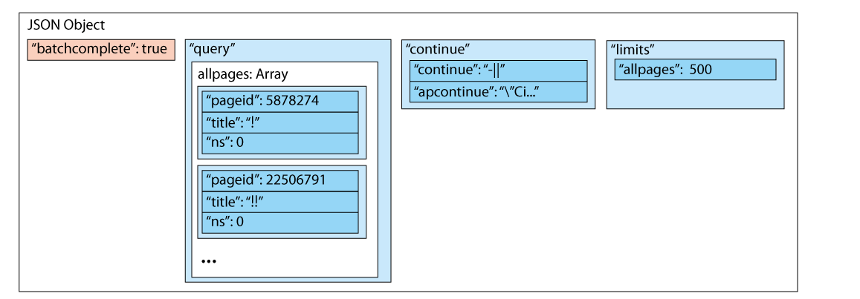

This request doesn’t have the pages attribute in the ‘query’, because it is a list. It, instead has the allpages attribute with objects, representing the required results. The limit ‘allpages’ informs the user what the maximal amount of items in list the server can send. Then the continue attribute can be used to go on with our query and get more pages that go after this one in the list. The page titles are starting with ‘!’ because all the pages here are sorted by alphabet.

Note, that we could have combined these 2 requests and sent a request for both a list and a prop to the Wikipedia API server, which would then return to us all the information we asked for.